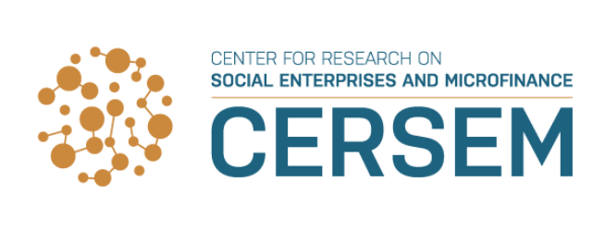

8th International Research Workshop in Microfinance,
Oslo, Norway, 27-28 September 2018

Call for papers

“Microfinance and Financial Inclusion:
A Promising Banking Model?”

On 27-28 September 2018, Oslo Business School at OsloMet - Oslo Metropolitan University in partnership with The Center for Research on Social Enterprises and Microfinance (CERSEM) at the University of Agder are hosting a workshop entitled “Microfinance and Financial Inclusion: A Promising Banking Model?”
Microfinance as a solution to reduce poverty has been at the center of development research over at least the last three decades. A large part of this research, especially since the 2000s, focuses on measuring the impact of microfinance (using e.g. randomized control trials) on the living conditions of the poor. Recently, the focus of this research has shifted towards understanding how policymakers can increase the poor’s financial inclusion, i.e. the extent to which ‘…individuals and businesses have access to useful and affordable financial products and services that meet their needs – transactions, payments, savings, credit and insurance – delivered in a responsible and sustainable way of the poor.’ (World Bank) This research focuses on the demand side of microfinance. Less research has addressed the supply side, that is, the ways that microfinance institutions (MFIs) can contribute to increased financial inclusion of the poor as well as increased access for investors to the low-income banking segment.
This workshop provides a platform for high-quality research on the “business and finance of microfinance”. Microfinance is “banking in small amounts for underbanked populations”. Nevertheless, most high-quality microfinance research is published in development and economics journals and little is found in mainstream finance and banking journals. The aim of this workshop is to develop papers with publishing potential in highly ranked finance and banking journals. For that to happen we are interested in contributions that are not only of interest for the microfinance community but also for a wider banking/finance community.

We invite researchers to send in their work on one of the following topics (note that the list is not exclusive):
- Financial product innovation and financial inclusion
- Risk management
- Capital structure decisions and consequences
- Capital markets
- Ownership and its influence on policies and decisions
- Corporate governance issues
- Regulation
- Transformation of MFIs from NGOs to banks
- Downscaling by banks to microfinance markets
- Trade-off between financial and social performance
- Competition
- Mergers and acquisitions
- Entry and exit in microfinance markets
- Financial digitalization
- Financial behavior
- Internationalization
We invite scholars to submit their work for constructive discussions in a group of dedicated researchers. Papers can be both theoretical and empirical. The main selection criteria is the scientific quality of the paper. In addition, each paper must be of interest for the microfinance community as well as for a wider community of finance and banking scholars.
We aim to have presentations of around 20 papers. Scholars pay no fees to the workshop. Organizers provide lunches and a workshop dinner.
Scientific committee: Niels Hermes (University of Groningen, Netherlands), Roy Mersland (Director CERSEM, University of Agder, Kristiansand Norway) and R. Øystein Strøm (Oslo Metropolitan University, Norway).
We are working with well-known finance journals and hope to create a special issue for publication of the best papers from the workshop.
Send your paper to oystein.strom@hioa.no
Submission deadline: June 15, 2018.
Notification of acceptance to workshop: August 15, 2018.

